Reverse Mortgage TALC APPENDIX

Section 1026.33 defines a reverse mortgage and lays out the requirements for the Total Annual Loan Cost Rates (TALC) disclosure. The TALC disclosure must be provided three business days prior to consummation, but you will generally see this document in the initial disclosure package. Per Section 1026.33, the TALC disclosures must include:

- a statement that the consumer is not obligated to complete the transaction,
- a good-faith projection of the total cost of credit expressed as a table of “total-annual-loan-cost rates” (TALC rates),
- an itemization of loan terms, charges, the age of the youngest borrower, and the appraised property value, and
- an explanation of the table of total annual loan cost rates as provided in the model form found in Appendix K of Regulation Z

Examiners should refer to Appendix K to Regulation Z for detailed instructions on how to calculate the required TALC rates.

Appendix K to Regulation Z provides instructions on how to calculate the TALC rates required to be disclosed, based on the calculation method used in Appendix J for the closed-end APR, and provides a model and sample disclosure form. Appendix L to Regulation Z contains the loan periods creditors must use in disclosing the TALC rates and a table of life expectancies that must be used to determine loan periods based on the consumer’s life expectancy. Essentially, the TALC rates are the rates that cause the future value of all advances to the consumer—i.e. the initial lump sum, monthly payments, payments from the set-aside account for taxes/insurance, etc.—to equal the loan repayment amounts based on the different assumed loan periods:

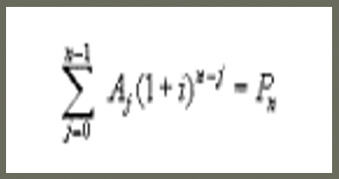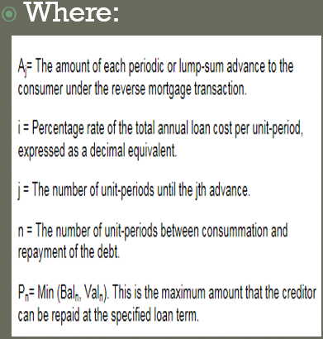

Section 1026.33 requires that the table show TALC rates for assumed annual housing appreciation rates of 0%, 4%, and 8%. It also requires that TALC rates be provided for the assumed loan periods of: two years; the consumer’s actuarial life expectancy; and the consumer’s actuarial life expectancy multiplied by a factor of 1.4. In addition, at the creditor’s option, the table may contain a fourth assumed loan period based on the consumer’s actuarial life expectancy multiplied by 0.5. Here is an example of the TALC disclosure:

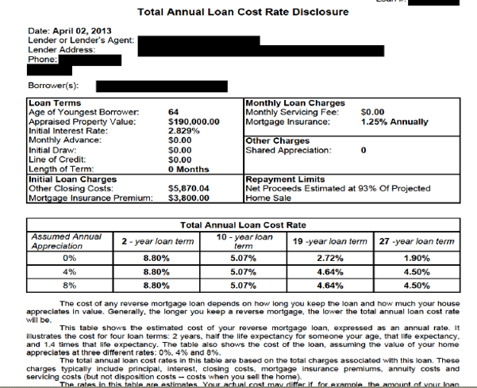

The commentary to § 1026.33 contains a number of clarifications. Comment 33(a)-1 clarifies that a transaction must be nonrecourse to meet the definition of a reverse mortgage in section 1026.33(a). That is, the consumer’s liability must be limited to the proceeds from the sale of the home. Comment 33(a)-1 clarifies, however, that if a closed-end reverse mortgage does not limit the consumer’s liability to the proceeds of the sale of the home, and the transaction meets the definition of a high-cost mortgage loan under § 1026.32, the transaction is subject to all the requirements of § 1026.32 and 1026.34. Comment 33(a)(2)-1 clarifies that the term “default” is not defined by the statute or regulation, but rather by the legal obligation and state or other applicable law. Comment 33(a)(2)-2 clarifies that to meet the definition of a reverse mortgage transaction, a creditor cannot require principal, interest, or shared appreciation or equity to be due and payable (other than in the case of a default) until after the consumer’s death, transfer of the dwelling, or the consumer ceases to occupy the dwelling as a principal dwelling. This comment further clarifies that the reverse mortgage obligation may state a specific maturity date or term of repayment and still meet the definition of a reverse mortgage, as long as the maturity date or term will not cause maturity prior to the occurrence of any of the maturity events recognized in the regulation. For example, the obligation could state a term but automatically extend the term for consecutive periods if no recognized maturity event has occurred. Comment 33(c)(1)-1 clarifies that all costs and charges the consumer incurs in a reverse mortgage are included in the projected total cost whether or not the cost or charge is a finance charge under §1026.4. Current comment 33(c)(1)-2 clarifies that the amount paid by the consumer for an annuity is a cost to the consumer and must be included in the TALC calculation. Comment 33(c)(1)-3 clarifies that costs incurred in connection with the sale or transfer of the property subject to the reverse mortgage are not included in the cost to the consumer.

Comment 33(c)(2)-1 clarifies that certain contingent payments to the consumer are excluded from the total cost projection. Comments 33(c)(3)-1 and 33(c)(4)-1 clarify that shared appreciation or shared equity, and limitations on the consumer’s liability, respectively, are included in the projected total cost. Comment 33(c)(4)-2 provides a uniform assumption that, if the consumer’s liability is limited to the “net proceeds” from the sale of the home, the costs associated with selling the dwelling should be assumed to be 7 percent of the projected total sale price, unless another amount is specified in the legal obligation. This assumption regarding net proceeds can affect the TALC rates at the 0% appreciation assumption level since the house value may be less than the loan balance. In this case, the loan repayment amount would be:

House value*0.93

Commentary to Appendix K and Appendix L provides further guidance on calculating TALC rates and on the clear and conspicuous standard for the model disclosure form. The ComplianceEase software now has a Reverse Mortgage Tool that allows examiners to verify the accuracy of companies’ TALC disclosures. Although not explicitly stated in Regulation Z, most states permit a 0.125% tolerance for TALC rates, which matches the tolerance level for APRs.

